**REGex Software Services**

**Java Full Stack Development Program**

Registration I'd:  **IIPRSS1404**

Name: **Shanmukh Subhash Kumbhar**

Subject: Assignment **8** - #**OOPs Session 2**

Core Java 2022 **Core Java Session 8 Assignments**

**Develop the following using methods:**

1. print even number up to 10

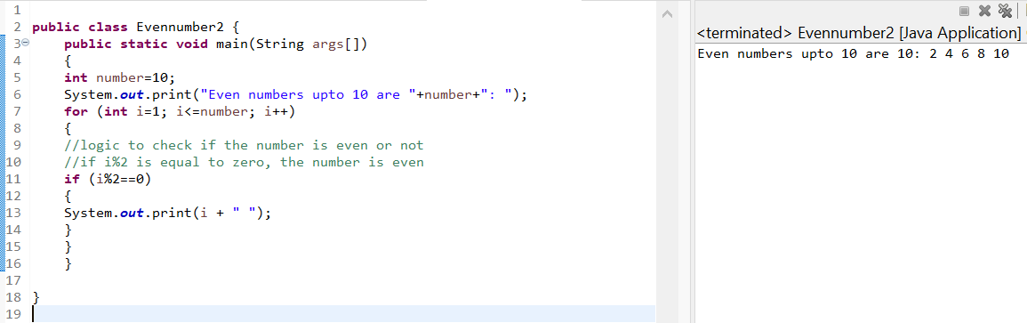

1. print odd number up to 10

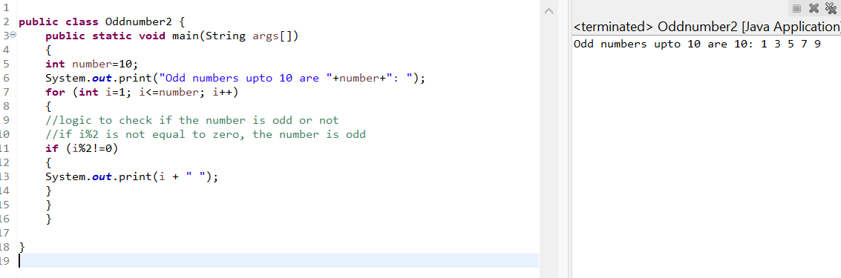

1. Find the factorial of the given number

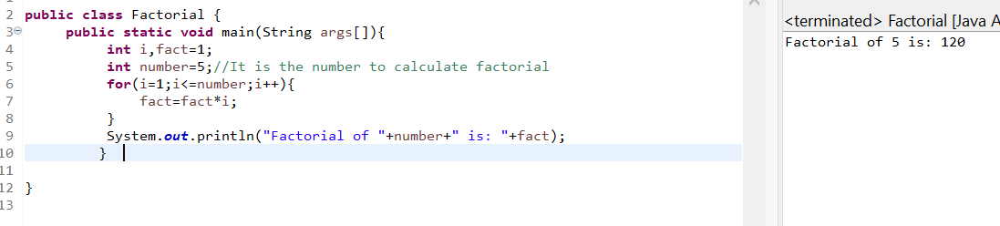

1. print the multiplication table for the given number

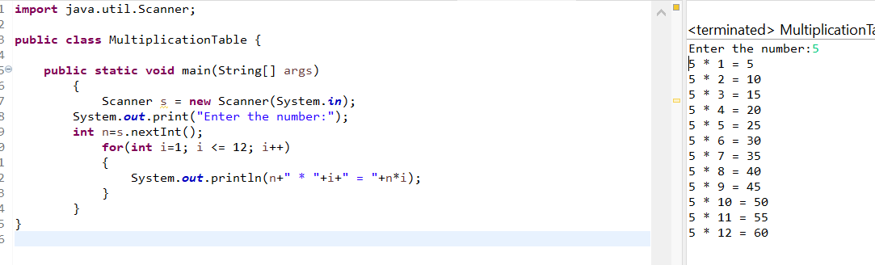

1. check whether the given number is prime or not.

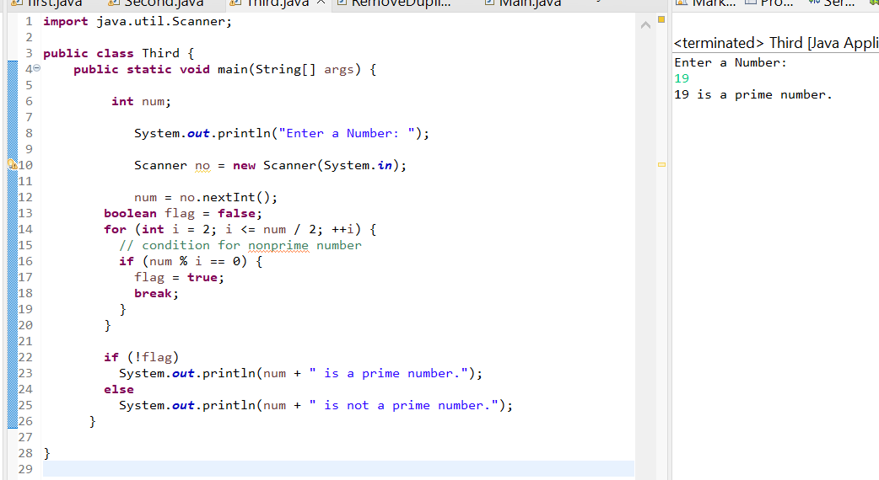

1. Write a method to find max of 3 numbers.

1. Write a method to find whether the given number is odd or even.

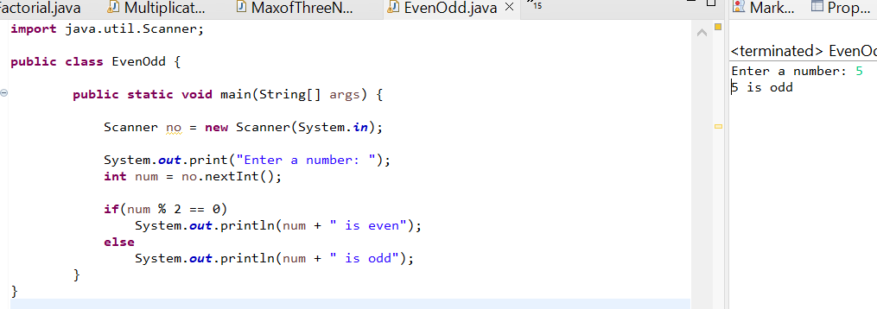

1. Write a method to check whether the given number is odd or not. (return true/false)

**Assignment 1:**

**Develop Student Progress Report App using methods.**

|  |
| --- |
| Accept **student id, name and marks of 6 subjects**.  Calculate **total marks, average, min marks, max marks, result.**  Display **Student Id, Student Name, Six subject marks, total marks, average min marks, max marks, and result**. |

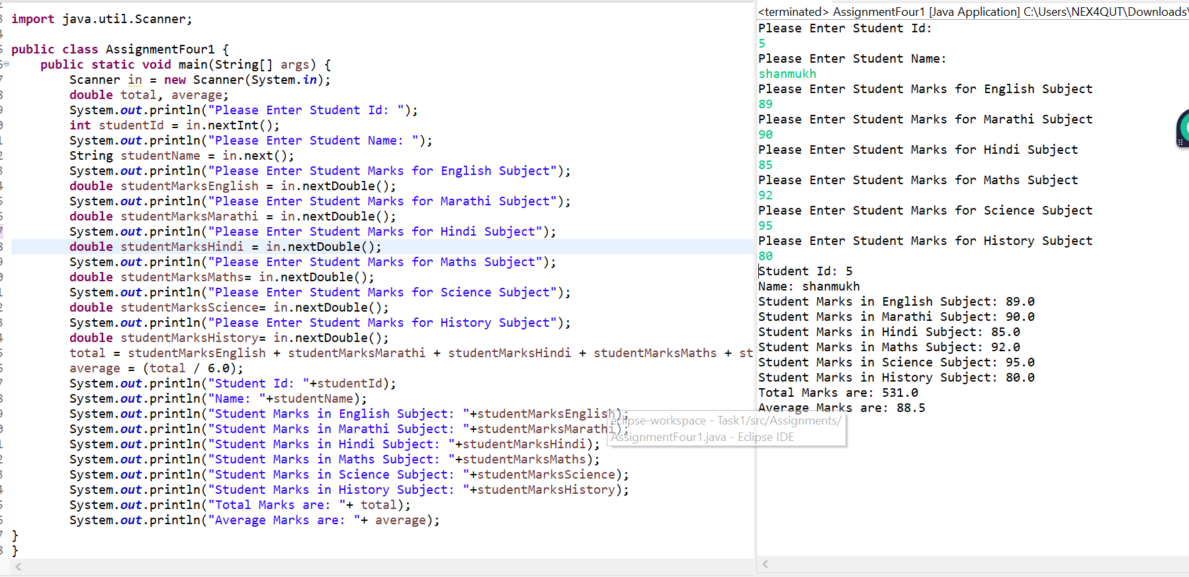

**Assignment 1:**

**Develop Employee Salary Breakup App using Methods.**

|  |
| --- |
| Accept **Employ Id, Employ Name, Basic Salary** from end user.  Calculate based on following constraints  **HRA is 2% of Basic**  **PF is 3% of Basic**  **TA is 1% of Basic**  **ESI is 2.5% of Basic**  **Gross Pay is Sum of Basic, HRA, PF, ESI and TA**  **Net Pay is Gross Pay minus PF.**  Print  Employ id, employ name, Basic Sal, hra, pf, ta, esi, Gross Pay, Net Pay as following |

**Input:**

Enter Employ Id : 10101

Enter Employ Name : Jones

Basic Salary : 10000

**Output:**

Salary Break Up Application

===================================================

Employ Id : 10101

Employ Name : Jones

Basic Salary : 10000

HRA : 200

PF : 300

TA : 100

ESI : 250

Gross Pay : 10850

Net Pay : 10550

